PRACTICAL:- 1
AIM:-

IDLEToolInstallationandTestabasicpythonprogram in both scripting and interactive mode.

STEP–1.TodownloadIDLEpython,firstlysearchIDLEpythonongoogleand then click on the original website of python.

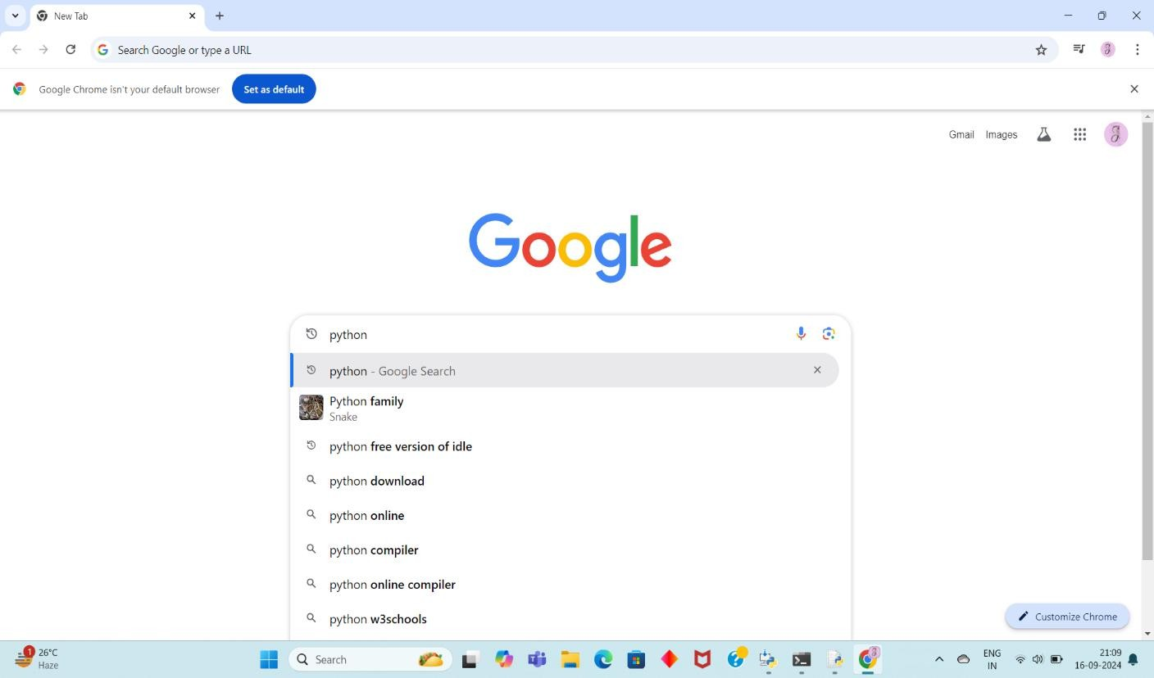

STEP–2:-Clickontheoriginalwebsiteofpython.
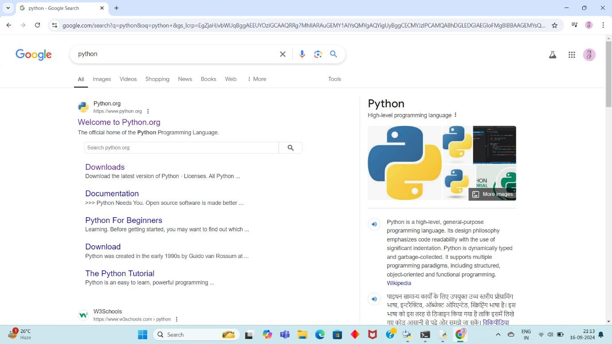

STEP–3:-Now,clickonthelatestversionofIDLEPythonanditstart downloading.

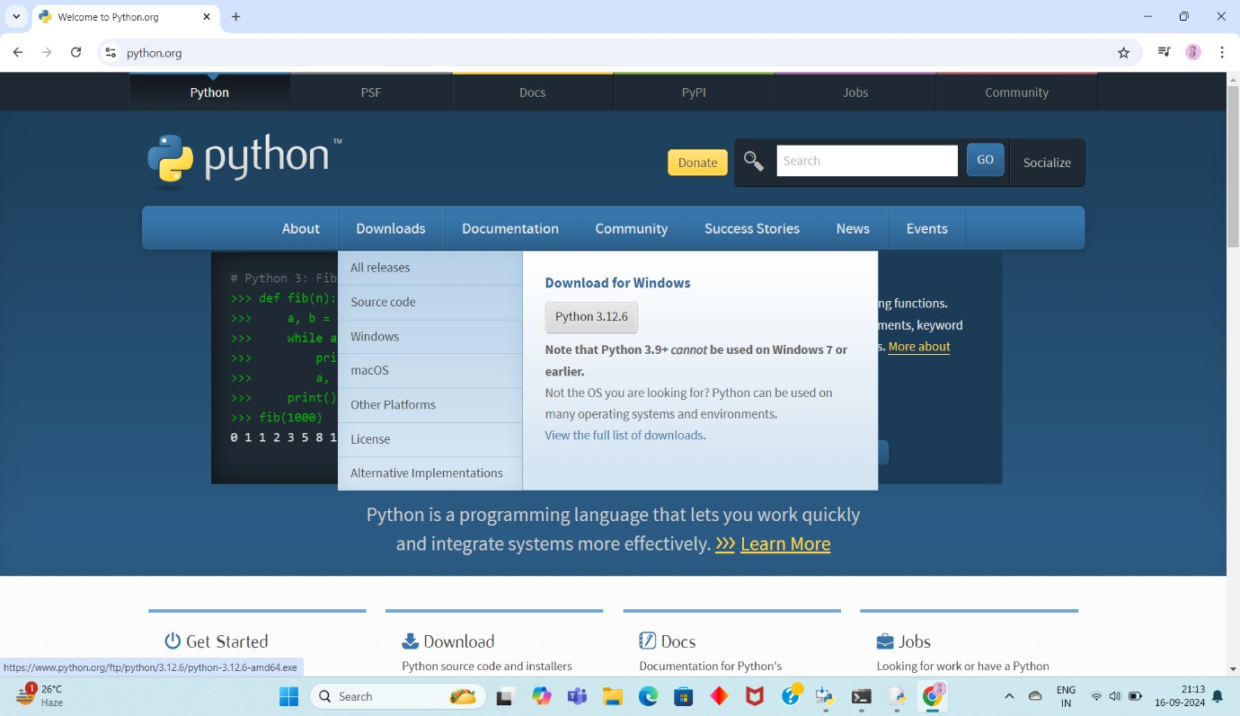

STEP – 4 :- After completing your download of IDLE Python, check

thatyourIDLEpythonissuccessfullyinstalledinyourdeviceornot.
So,tocheckthisopencommandpromptandcheckyourpython
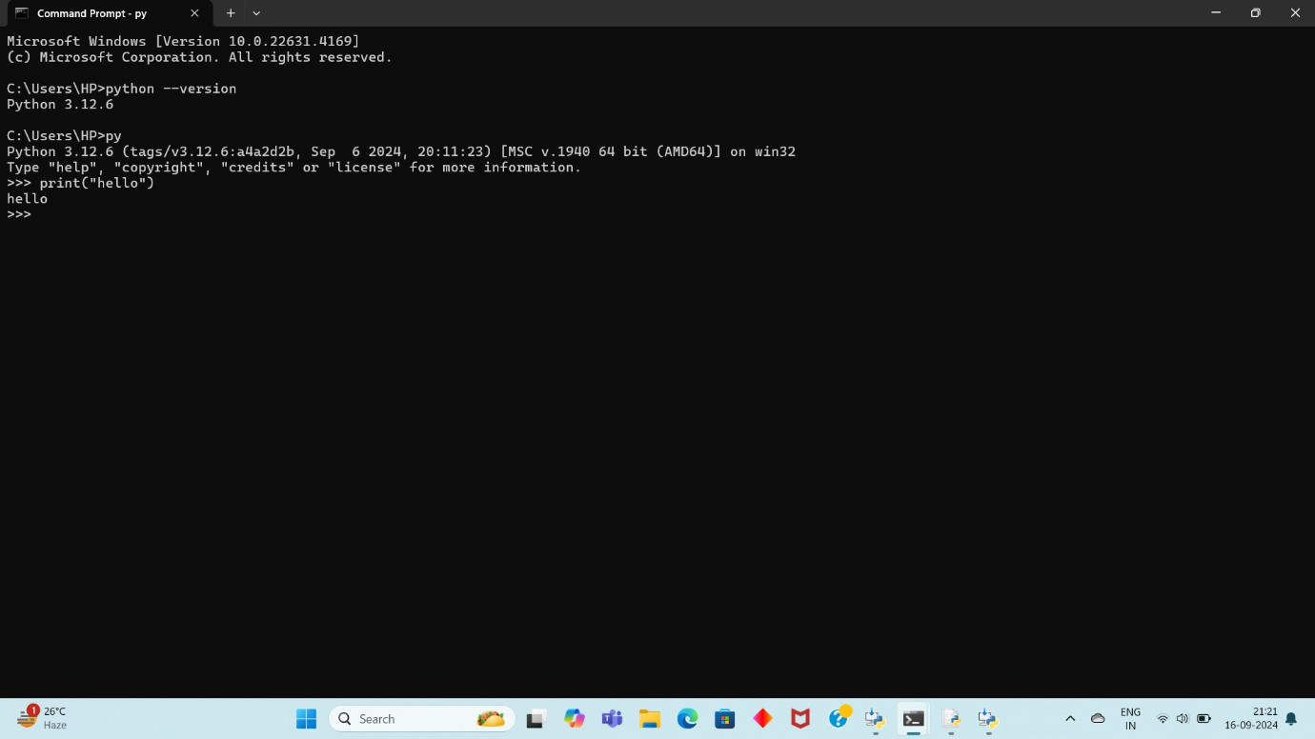
versionandafterthatmakeasimpleprogramandrunthatprogram
.

STEP–5:-Now,openIDLEPythonandrunyourprogram.

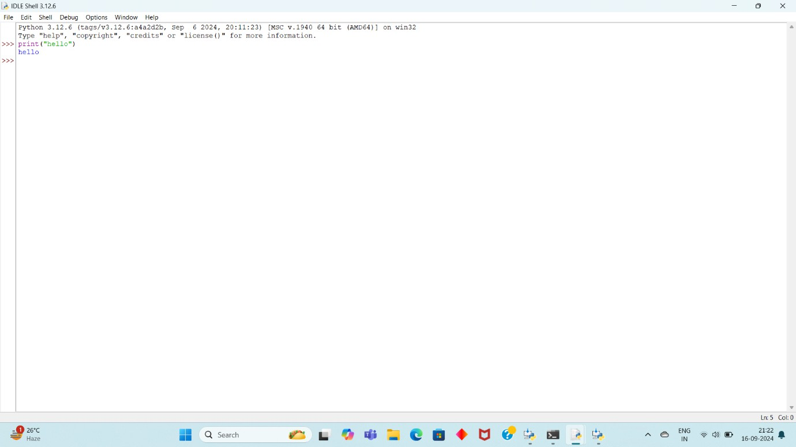

Result:

I have successfully installed IDLE on my PC, enabling me to run programs and develop projects efficiently. IDLE has greatly enhanced my coding experience.

